#Agent mapping

Manage Jenkinssystemnodes
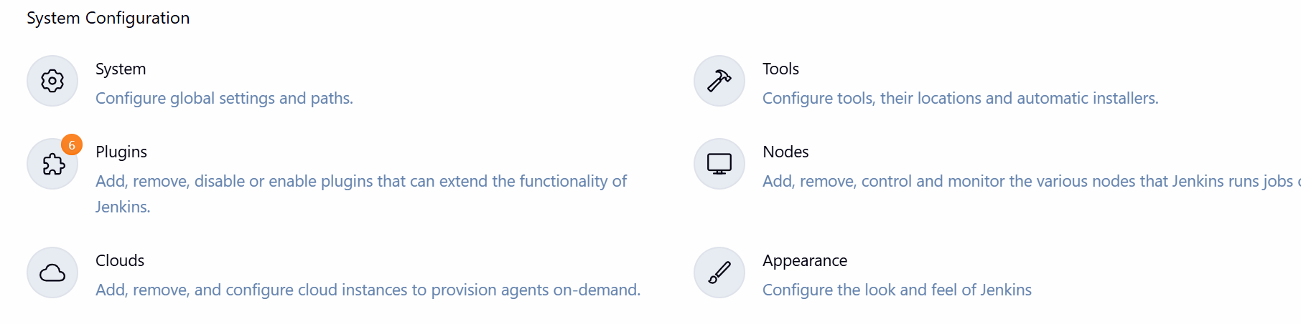
Add new node
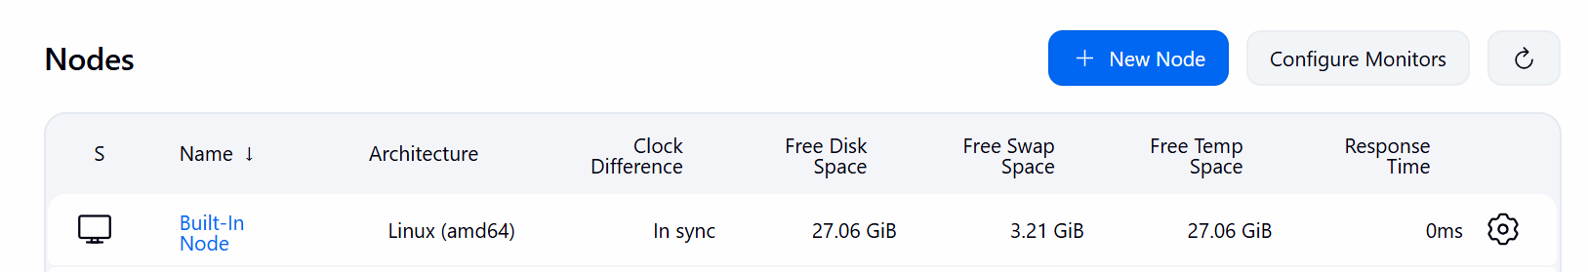

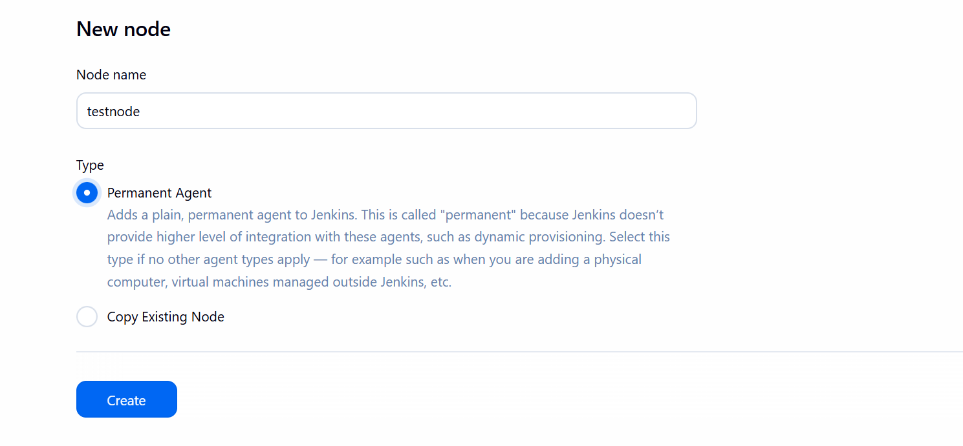

Click on Create

Option to selects:
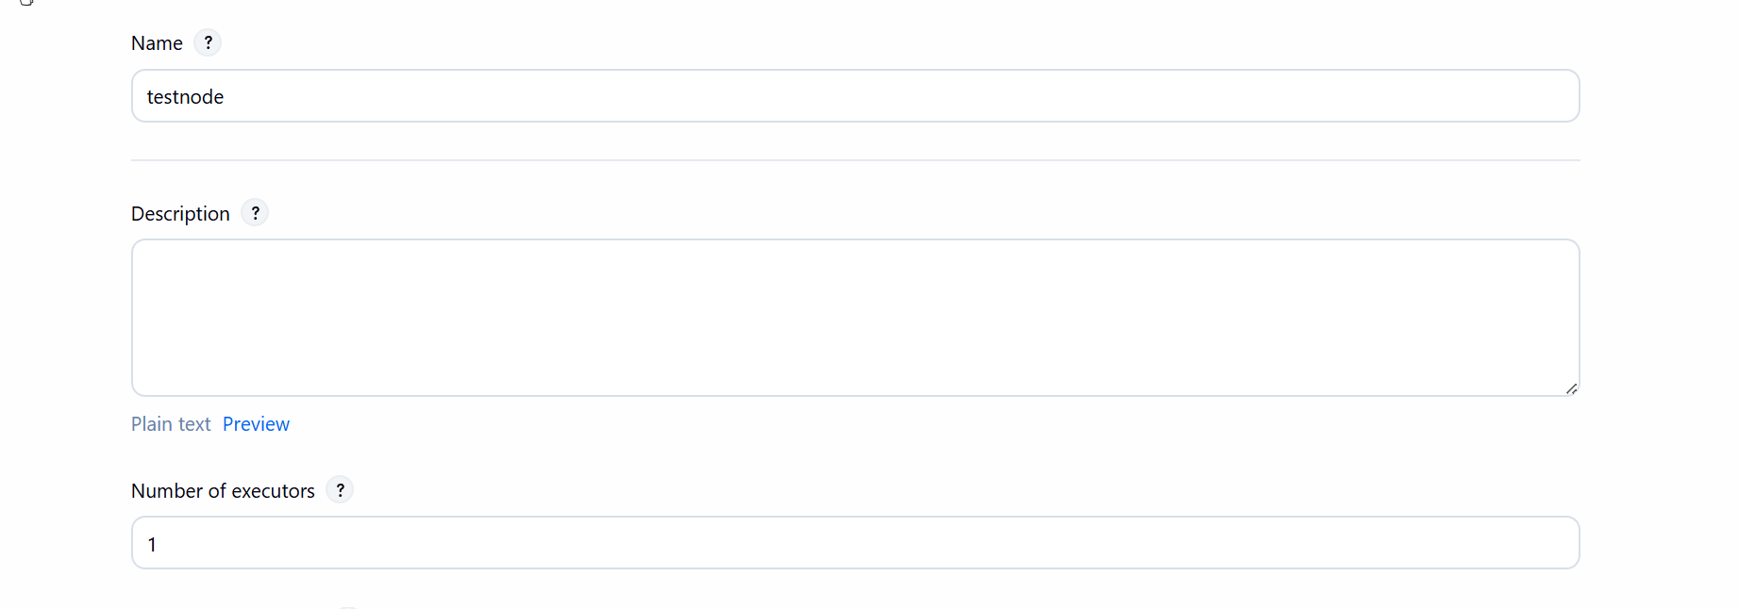
Provide your linux machine current user home directory:
Example: myuser is amit, then home directory is : /home/amit
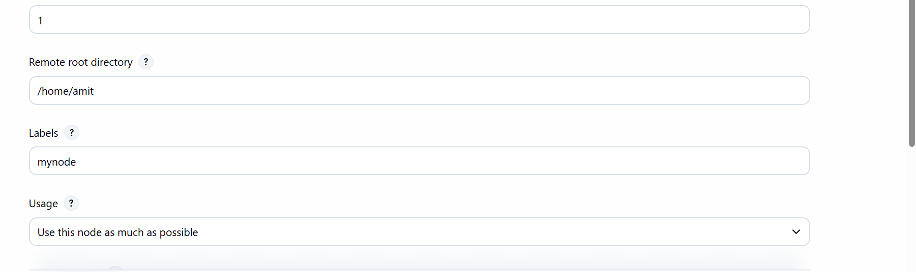
Provide the label
Launch method: via ssh

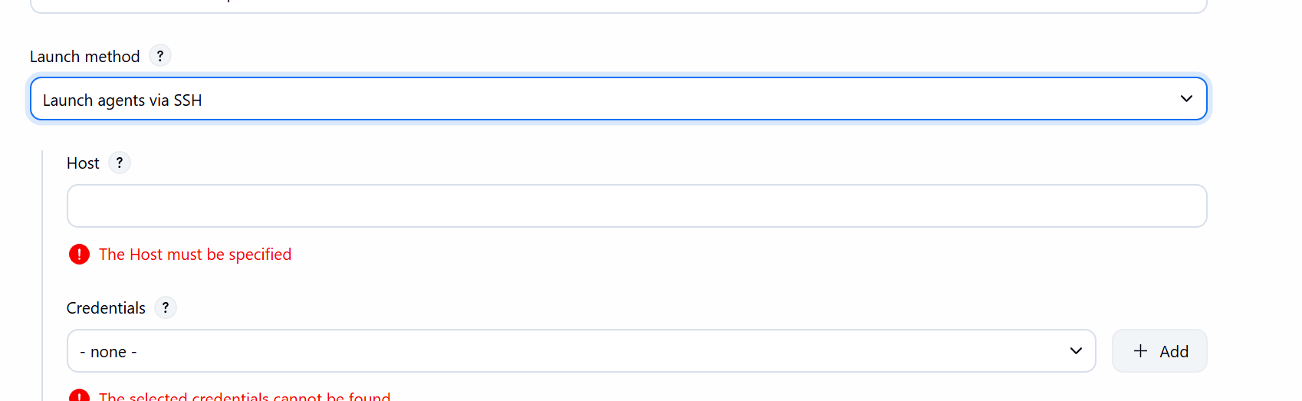

Provide your server details and for credentials click on add (Jenkins)
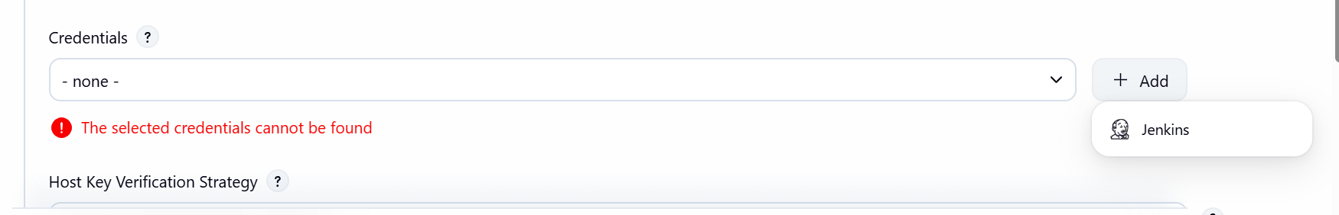

Provide your usrname and password
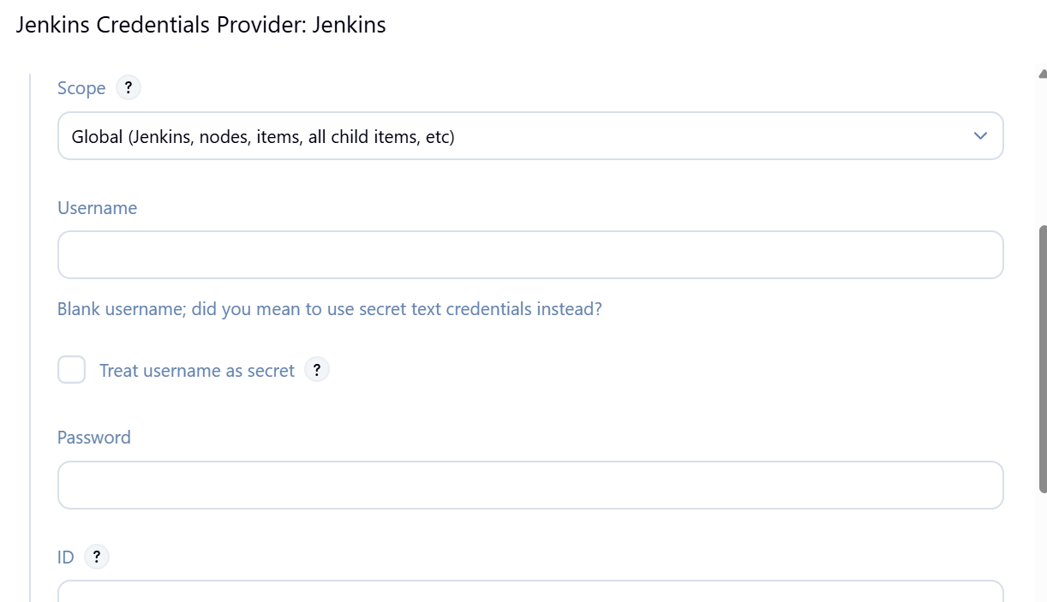

Click on Add
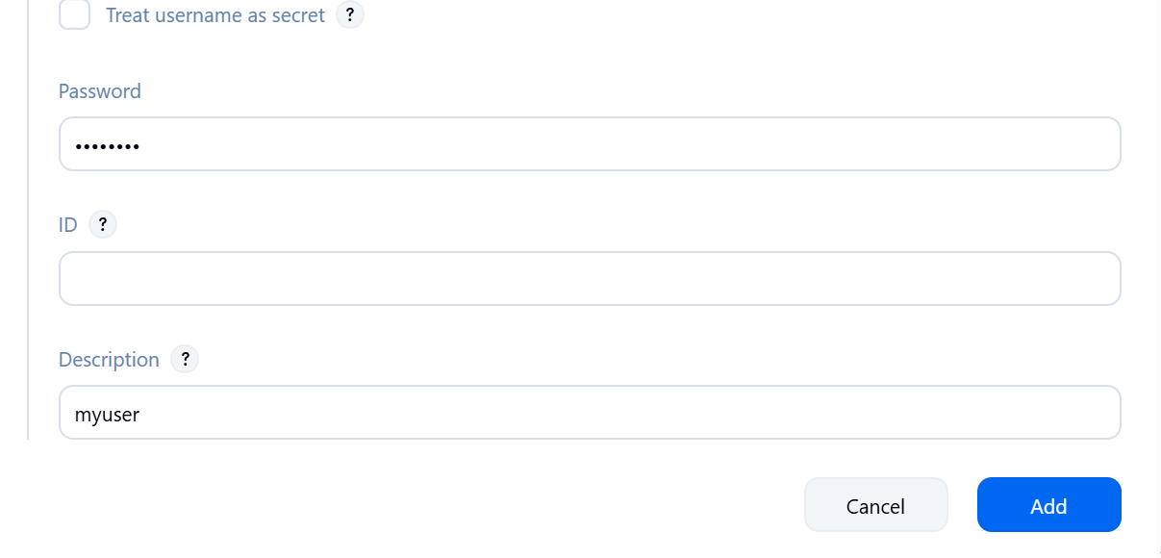
Select the user and strategy: Manually trusted
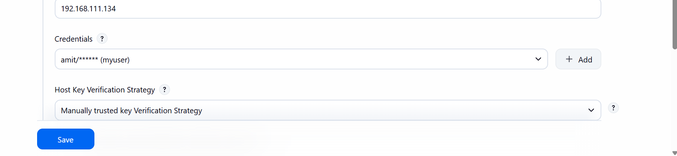
Click on save
Check the Node
